**Project Development Phase**

|  |  |
| --- | --- |
| Date | 05 November 2022 |
| Team ID | PNT2022TMID18706 |
| Project Name | Visualizing and Predicting Heart  Diseases with an Interactive Dash Board |

Sprint-3

**Exploring Dataset-** The data set would be explored to find the general trends ofthe data

# set.

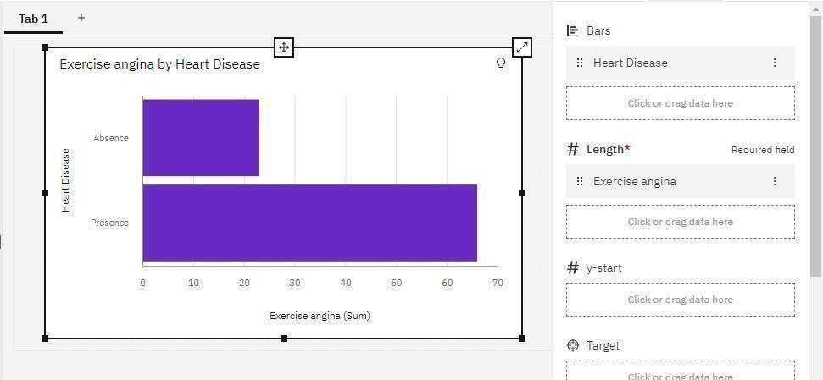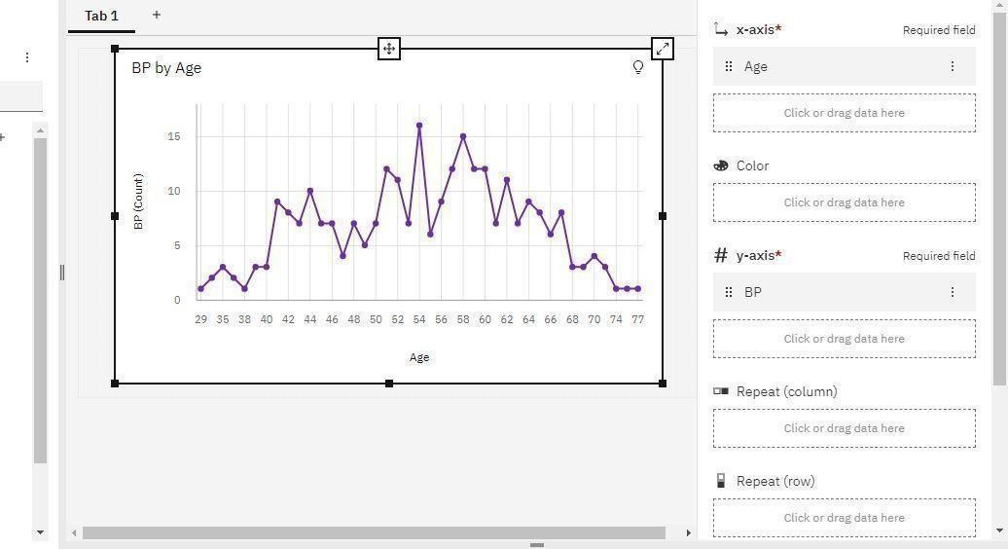

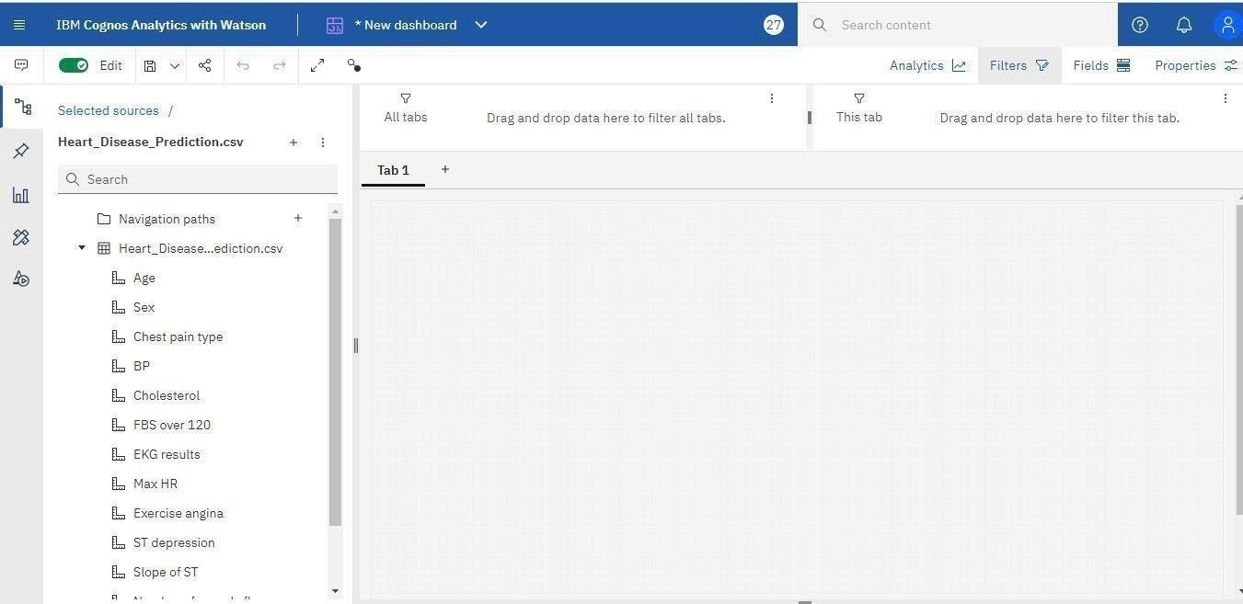

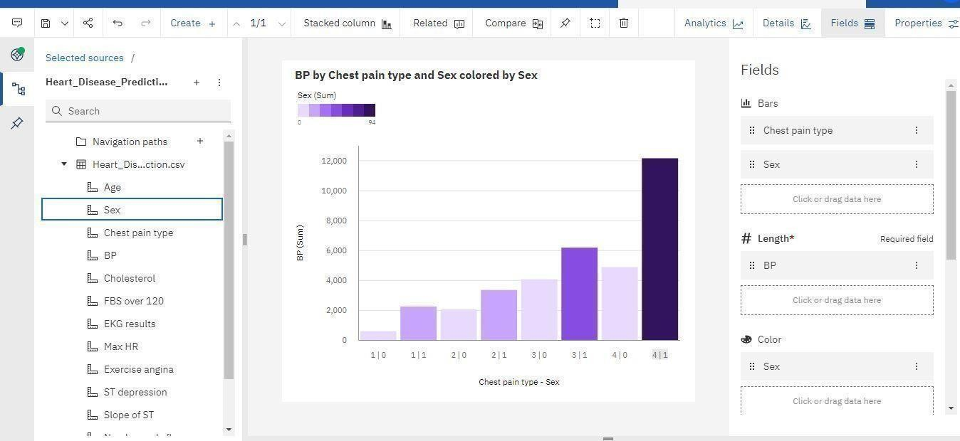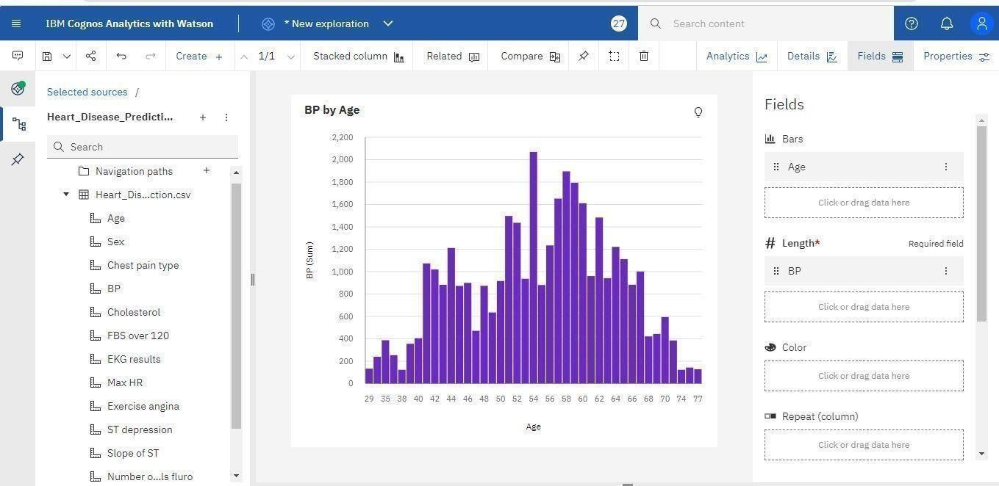

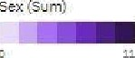Hear+_Disease_Pedi+... C holes4erol by Sex and Age volored my Sex

 

.inn *- s ‘i

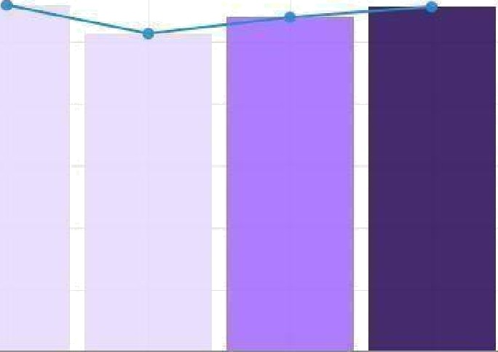Age and Age foi Chest pain type colored by Sex







## Ghsst pain type, Age and Age by Sex

fMeesuree

 

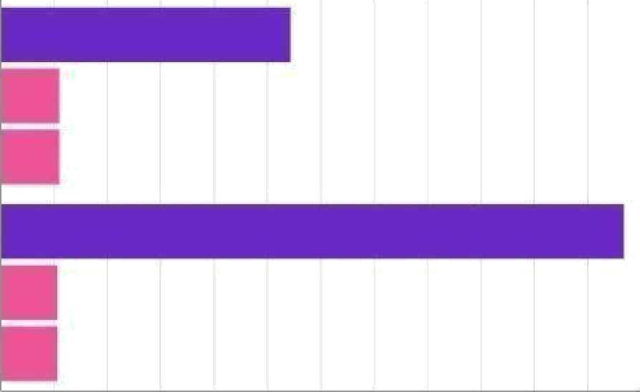



Age by Chest pain type and Sex

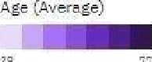



Fields

## s Bar

@ LengLh“

.. Chest pain type

:: Age

.. Age

GNkor.dzegdatehere

i /ig k or drag data here

Fields

Rows

.. Mest ppin tyge

. Sex



. Age

§. Heat“

**Working with Dataset -** The Data Should be Evaluated and make useful for the Project.

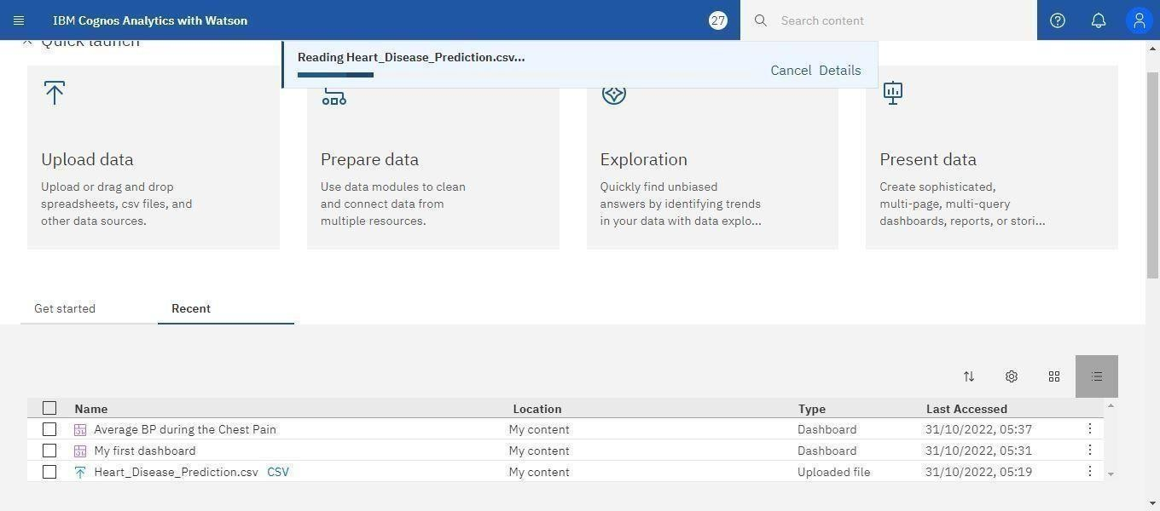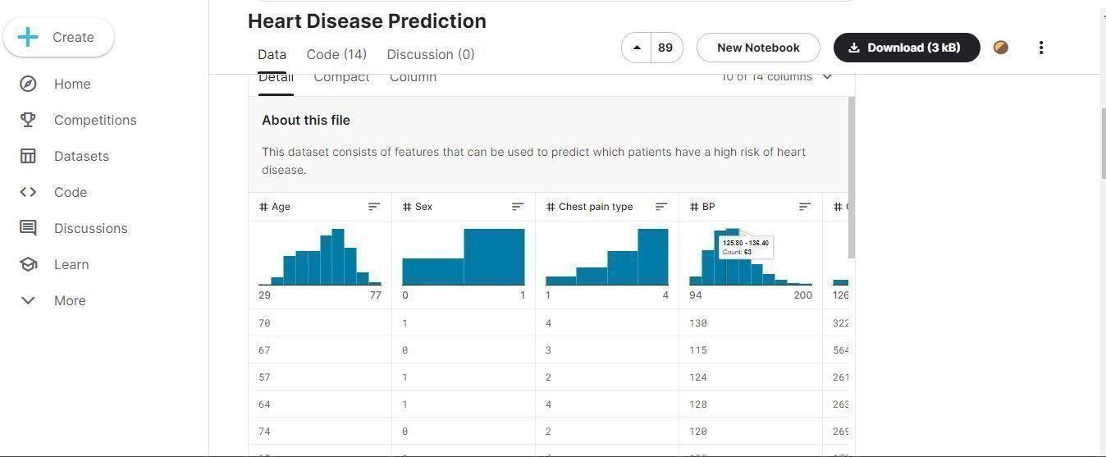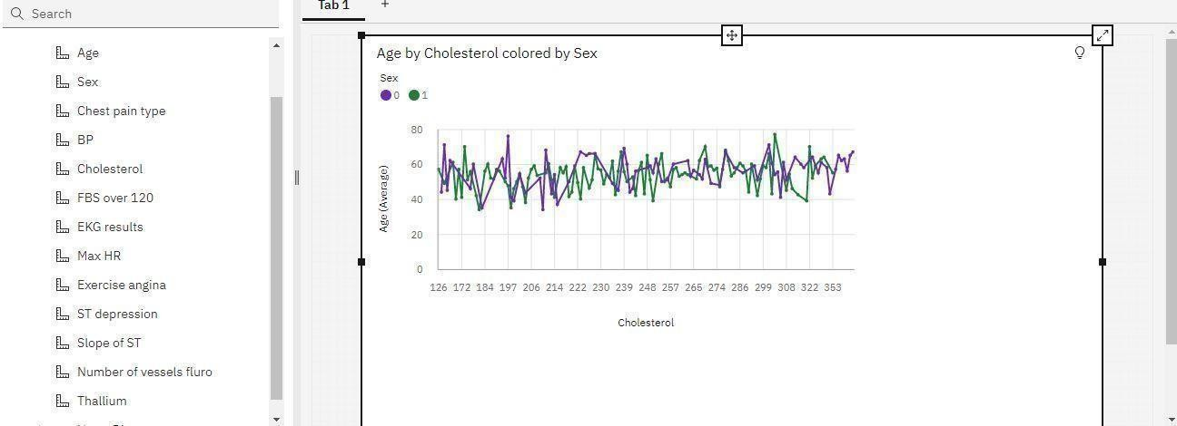

# 



U p load data Prepare data Exp loration Present data